**Project Test (Kiva)**

Kiva's lending platform serves as a bridge between lenders and borrowers, fostering financial inclusion, reducing poverty, and promoting economic development in communities that may have limited access to traditional financial services.

My task included data collection and reporting, including the use of KPIs, allow the organization to make informed decisions, optimize its lending processes, and continually improve its impact.

**KPIs**

* Loan Repayment Rate: 96% of repayment rate by Kiva’s borrowers
* 86 Countries and 13.6M lenders
* Total funded amount so far 1.6B $
* Over 77% Female assisted

**Metrics**

1. Loan Funded Percent: This helps measure the percentage of the loan amount that has been funded by lenders. It provides insights into how much of the requested loan amount is being fulfilled.

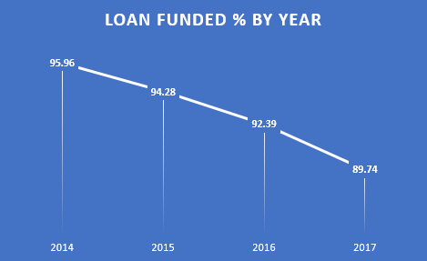

As you can see the percentage has been reduced over the year of time.

Pros: Straightforward and easy to understand.

Helps assess the efficiency of fundraising efforts.

Cons: Doesn't account for the timing of funding, which can be important.

e.g, a loan might be fully funded but take a long time to reach that point with multiple lenders.

1. AVG Time Taken To Fund: This will help measure how long it takes for a loan to be fully funded from the moment it’s posted. It’s calculated as the difference between ‘funded_time’ and ‘posted_time.’

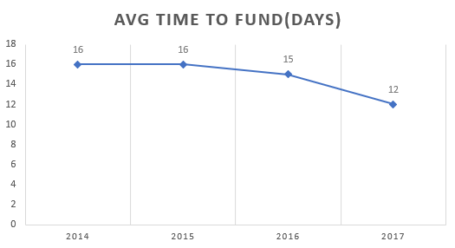

Its quite visible that reducing the duration over the years going to attract more users, with this metric we can understand what loans don’t get funded quicky and what could be their reason.

Pros: Measures efficiency in attracting lenders.

Identifies loans that take an unusually long time to fund.

Cons: Limited to loans that get funded, doesn’t include the loans which don’t get funded.

1. AVG Loan Disbursement Time: This measures the speed at which Kiva disburses loans to borrowers after their loan requests are posted on the platform.

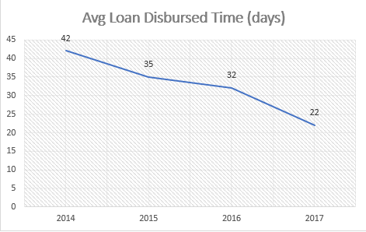

Lesser the duration, better the user experience

Pros: A shorter LDT indicates that Kiva is responsive to borrowers’ needs. Borrowers receive funds faster, allowing them to act on their financial requirements promptly.

Cons: LDT can vary significantly based on factors such as the loan’s complexity, borrower location, and processing time by field partners

Some Metrics I think I are equally important:

Borrower’s Retention Rate: (repeated borrowers count / total unique borrowers count)*100

Average Loan Duration length By Sectors: This metric helps understand the typical duration of loans in different sectors, which can be crucial for planning and resource allocation.

**Short Analysis of Loan Disbursement of Time**

Loan Disbursement Time measures the speed at which Kiva disburses loans to borrowers after their loan requests are posted on the platform. A shorter LDT can improve borrowers’ access to funds, enhance the user experience, and potentially lead to higher satisfaction and trust in Kiva’s services

Calculation:

LDT = (Loan Disbursement Date – Loan Posted Date)

Detailed Analysis:

A low LDT is generally favorable, as it implies that borrowers receive funds quickly. Analysing LDT over time can reveal trends and areas for improvement. For instance, if the average LDT decreases, it indicates that Kiva is becoming more efficient in disbursing loans.

However, the analysis should go beyond averages. Break down LDT by factors such as region, loan type, or field partner. Are there regions where LDT is consistently high? Are certain loan types processed faster than others? Such insights can help identify bottlenecks and areas for targeted improvements.

Why should you have LDT?

Implement real time monitoring of LDT to identify delays promptly. This can involve automated alerts for unusually long processing times

Analysing LDT for different borrower segments can help us understand variation in disbursement time.

We can aim to improve LDT over time and compare its performance against historical data

Challenges I faced:

Data Preprocessing took longer than expected due to inappropriate Date/time format, disbursement timing and posted timing have been recorded wrongly (there are negative values if tired to calculated difference for LDT).

A lots of garbage records, including blank values.

Outliers and positively skewed data

Huge data for my pc to handle

Tools: Python & Excel

Approach:

I used to python to handle data preparation quickly, python gives the flexibility to clean data and make necessary changes.

Data Analysis and Visualization done in Excel, with Excel Power Query fixed errors with large data, created metrics and KPIs building along with reporting.

Analysing LDT and identifying areas for improvement can enhance the efficiency of Kiva’s operations while maintaining the quality of its services.

**Files Used in the Project**

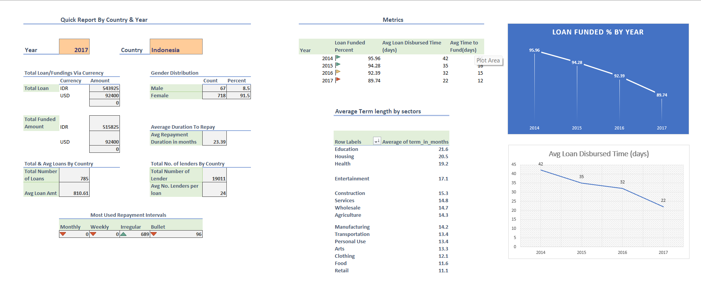

Drive link for folder: <https://drive.google.com/drive/folders/1VqrnKsUbIl62KxkjSHWWlG4OPwH6g-u9?usp=sharing>

Folder includes: docx, xlsx & ipynb

Open workbook for interactive analysis.

Project Analysis By

-Nikhil Jagtap